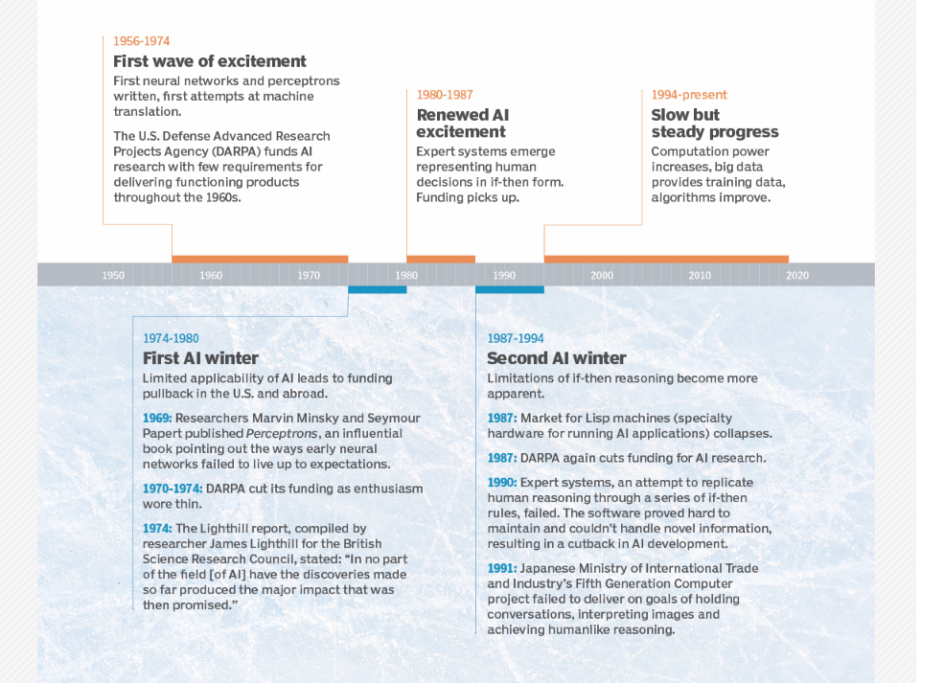**AI** **WINTER**

AI winter is a quiet period for artificial intelligence (AI) research and development.

The label winter is used to describe dormant periods when customer interest in AI declines.

Use of the season winter to describe the resulting downturn emphasizes the idea that the quiet period will be a temporary state, followed again by growth and renewed interest.

*The trajectory of AI has been marked by several winters since its inception in 1955 in a formal proposal made by computer scientist and AI researcher Marvin Minksy and several others.*

*Between 1956 and 1974, the U.S. Defense Advanced Research Projects Agency (DARPA) funded AI research with few requirements for developing functional projects.*

*In 1969, Minsky and another AI researcher, Seymour Papert, published a book called Perceptrons, which pointed out the flaws and limitations of neural networks. This publication influenced DARPA to withdraw its previous funding of AI projects.*

*In 1973, an Academic Research in field of AI called the "The Lighthill Report" was published. It was highly critical of research in the field up to that point, stating that AI research had essentially failed to live up to the grandiose objectives it laid out. This report caused the U.K. to cease funding for AI.*

AI winters occur because vendor promises have fallen short & AI initiatives have become more complicated to carry out than promised.

*When AI-washed products fail to deliver a significant return on investment (ROI), buyers become disappointed and direct their attention elsewhere.*

***AI winters occur when the hype behind AI research and development starts to stagnate.***

**It also happens when functions of AI stop being commercially viable.**

Promises generated by new techniques tend to create a large amount of buzz and raise the public's expectations. Businesses and organizations invest a lot of money based on these expectations, and gradually over time, if the new technology fails to deliver on those expectations, they lose interest in AI.

Although the new advancements have been influential, they also have significant limitations that prevent broad applicability and ubiquitous, cross-contextual use.

**To forestall another AI winter, some vendors have chosen to label software features predictive instead of artificially intelligent.**